FOHOW HEALTHCARE PRIVATE LIMITED
2ND FLOOR, HOUSE NO. 213, GURUDWARA ROAD, SOUTH CITY 1,
GURUGRAM HARYANA,122001
CIN: U47990HR2025PTC133261
Email: [dr.singh@fohow.com] | Phone: [+91-8802856563]

Compensation POLICY
(As per Consumer Protection (Direct Selling) Rules, 2021)

Direct selling is the distribution method employed by FOHOW Healthcare, and other network marketing companies, where products are sold person-to-person, away from a fixed retail location.
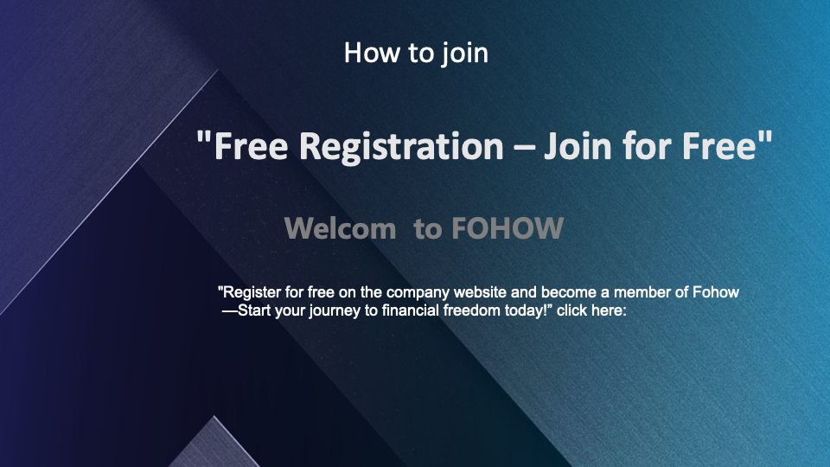
Zero Joining cost as a Associate –
To start your own home-based FOHOW business, Complete a direct seller Application form and purchase a Business Development System Kit for as little as Rupee 3000, you get a tried and tested system for creating an income-generating business that can last a lifetime.
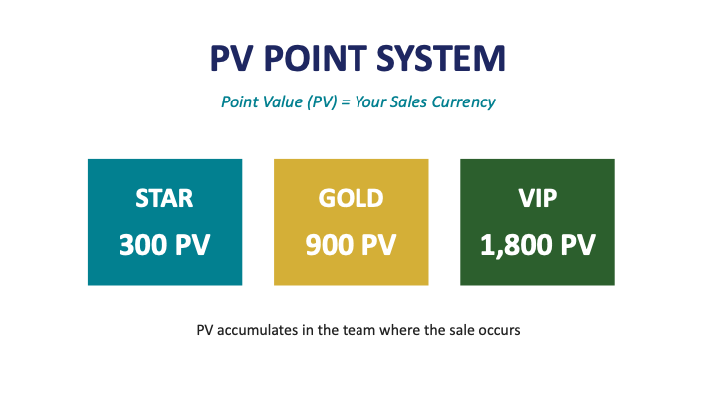
Qualified Distributors –
Order FOHOW products that total 100 points and become a qualified HERO distributor of FOHOW products. You will participate in reward assessment and gets rewarded according to bonus plan. With nearly 60% going back to Associates in the form of commissions, FOHOW offers the highest payout percentage of profitable reporting companies in the industry.
💳 MEMBERSHIP LEVELS (A)
Level | PV Required | Investment (₹)
Hero Card | 100 PV | ₹15,750
🥈 Star Card | 300 PV | ₹47,250
🥇 Gold Card | 900 PV | ₹1,41,750
💎 VIP Card | 1800 PV
Note: You can upgrade anytime by purchasing the corresponding package

FOHOW Binary compensation system allows more individuals become wealthy and be financially free. The FOHOW Binary Compensation Plan is a binary system in which you build balanced left-side and right-side downline organizations for the purpose of selling FOHOW’s nutritional and personal care products. Your sponsor places you in an open position in his or her sales organization. The weekly commissions you earn are based on the balanced Group Sales Volume (GSV) points accumulated in your left-side and right-side downline organizations.
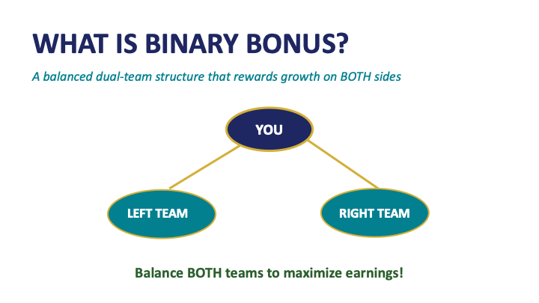
- No monthly group volume and personal volume requirement
- Seamless Global Plan
- Unlimited Growth Opportunity
- Multiple Ways To earn Money
- Online Business Building Tools
- Teamwork Incentives
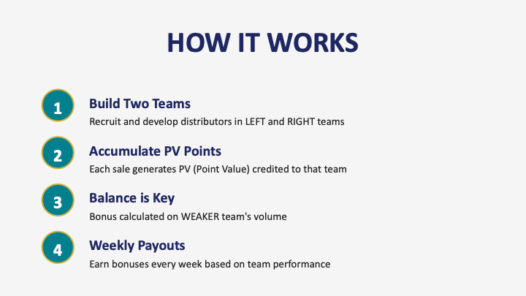
A unique aspect of the Binary Compensation Plan is that you and everyone under your upline are able to build your downline. This structure creates a synergy wherein everyone benefits when new Associates are added.

💰 B01 - RECOMMENDATION BONUS
Bonus Rate | Features
10% | Unlimited Cycle | No Cap | Quick ROI
✓ Direct recommendation of higher-level distributors earns 10% bonus

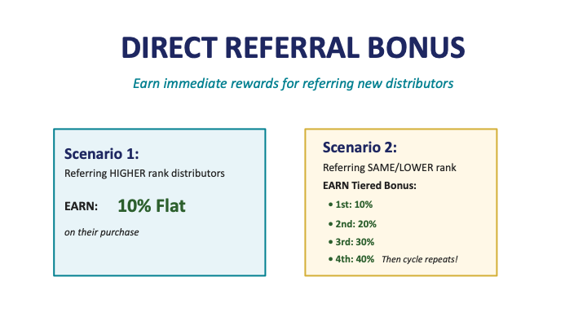

Development Bonus
Level | Rate 1 | Rate 2 | Rate 3
🥈 Silver | 12% | - | -
🥇 Gold | 12% | 6% | -
💎 Platinum (VIP) | 12% | 6% | 2% (NO CAP!)
Weekly Maximum Cap: Silver ≤ F$1,000 | Gold ≤ F$3,000 | Platinum ≤ F$9,000 (per position)
🌟 VIP Members earn: 12% + 6% + 2% (GLOBAL FIRST: 2% with NO CAP!)

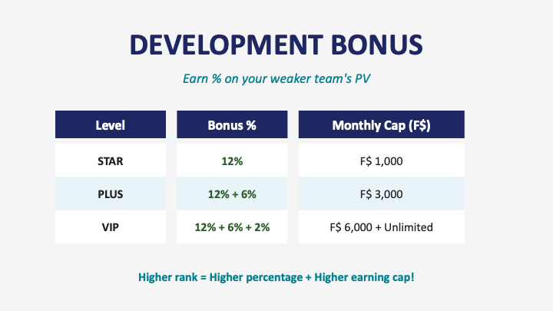

GUIDANCE BONUS- Single Line Earnings!
Your Level | Generation 1 | Generation 2
🥇 Gold / 💎 VIP | 5% of Gen 1 Development Bonus | -
💎 VIP | 5% of Gen 1 Development Bonus | 5% of Gen 2 Development Bonus
✓ Single-line can be unlimited! More recommendations = More income | Higher level = More income

Global Leadership Bonus
Become a top leader who helps other succeed and you will be eligible to receive a share in the profits for your excellent sales performance. Every week, FOHOW reserves five percent of its global sales volume and divides it among qualifying diamond distributor and above to support building and training new leaders.

GLOBAL DIVIDEND - Work Hard, Earn More!
Rank Required | Dividend Type | Share %
≥ 3-Diamond | Monthly Dividend | 0.5%
≥ 5-Diamond | Quarterly Dividend | 0.5%
≥ 7-Diamond | Annual Dividend | 1%
≥ Phoenix Ambassador | Annual Dividend | 2%
Share Calculation: Each operating position generating >F$1,000 development bonus = 1 share

Global Fohow Ambassador Bonus Reward
All the Fohow ambassador distributors can participate in Fohow Ambassador bonus which takes a proportion of 0.5% of global sale of every week

C - DISTRIBUTOR RANKS
Rank | Requirement (Any Position)
💚 Emerald | Team PV: 10,000
❤️ Ruby | Team PV: 30,000
💙 Sapphire | Team PV: 90,000
💎 Diamond (1-7 💎) | Team PV: 27,000 per position (1-7 Diamonds)
🏅 Phoenix Ambassador | 7-Diamond + Direct recommend 3 × 7-Diamond teams
✓ Rank only increases, never decreases | Lifetime honor once achieved!

💳 BONUS PAYMENT DISTRIBUTION
Item | Details
Cycle | Weekly (Mon-Sun), calculated next week, paid week after
90% to E-Wallet | For purchases & withdrawal (10% platform fee on withdrawal)
10% to Fund Account | Company adds +10% bonus, paid when rank achieved

KEY TERMS & DEFINITIONS
TERM | MEANING
PV (Point Value) | Points assigned to each product. PV is the basis for calculating rank qualification and bonuses.
BV (Business Volume) | The monetary value (in INR) assigned to each product, upon which commissions are calculated.
PPV (Personal PV) | PV generated from products you personally purchase and sell to consumers in a calendar month.
GPV (Group PV) | Total PV of your personal purchases plus the PV of all Direct Sellers in your downline network.
GBV (Group BV) | Total BV of your personal purchases plus the BV of your entire downline network.
Upline | The Direct Seller who sponsored you into the Fohow Healthcare network.
Downline | All Direct Sellers you have personally sponsored, and those sponsored by them, in successive generations.
Active DS | A Direct Seller who achieves a minimum of 50 PPV in a calendar month.
Retail Profit | The difference between the Maximum Retail Price (MRP) and the Direct Seller Price (DSP) you pay to the Company.
Performance Bonus | Monthly commission earned on your GBV based on your qualifying PV slab and rank.
Differential Bonus | The difference in bonus percentage between your rank and your direct downline's rank, paid on their GBV.

Explanations
- PV – PV means Point Value. PV is worked out by dividing sale by the conversation rate between standard money and PV.
- PV is the uniform performance point volume unit of Fohow Company.
- Cycle reward is settled up weekly and granted on Tuesday in the third week
- Global bonus reward is settled up weekly and once a season
- Different rewards can concurrently be obtained
- Granting of special reward fund complies with Global special fund granting enforcement regulation.

Note: Fohow Healthcare reserves the right to amend, adjust and explain this reward plan.

Retail Sales
Earn profit on the sale of FOHOW products when you collect the difference between wholesale and the retail price, which you set. Selling retail is one of the quickest ways to develop immediate income for your business while you start to build a long-term base of satisfied customers.

Weekly Commissions
FOHOW Business Centers are designed to pay you weekly commissions on Sales Volume with no limit to the number of vertical levels from which you can earn your commissions. In addition, a FOHOW Business Center allows you to be paid on the Sales Volume created by your downline Associates and Preferred Customers.
In Fohow, Monday is the first day of the assessment week and next Friday is the last day. The performance is assessed weekly. FOHOW Business Centers are designed to pay you weekly commissions on Sales Volume with no limit to the number of vertical levels from which you can earn your commissions. In addition, a FOHOW Business Center allows you to be paid on the Sales Volume created by your downline Associates and Preferred Customers.

Every distributor in Fohow is eligible to make retail profits by selling Fohow products and recommending others into career in Fohow. Earn up to 6 percent in commissions on the weekly Group Sales Volume (whole increments) accumulated in your group, generated by volume through product sales. FOHOW products are consumable, you will have a regular stream of income coming in as people re-order.
Carry Forward
Unlike other compensation plans, any extra volume (up to 10,000 points on each side) is carried forward to the following week.

RULES, POLICIES & COMPLIANCE

Activity Requirement
To be Active and eligible for Performance Bonus in any calendar month, you must achieve a minimum of 50 PPV through product sales to end consumers in that month. Months where you do not meet 50 PPV, you are considered Inactive and earn no bonuses for that month.

12.2 Payment Timeline
All commissions and bonuses are calculated on the basis of calendar month performance and are paid into your registered bank account by the [15th] of the following month. TDS shall be deducted at applicable rates as per the Income Tax Act, 1961.

No Income from Recruitment
In strict compliance with the Consumer Protection (Direct Selling) Rules, 2021, no bonus or commission is paid for the mere act of recruiting or sponsoring a new Direct Seller. All income is traceable to actual product sales.

Anti-Stockpiling Policy
Direct Sellers should not purchase products with the intention of stockpiling. You are encouraged to sell at least 70% of all products purchased before placing a new order. The Company reserves the right to monitor purchase patterns and restrict orders that appear to be inventory-loading.

Rank Qualification
Ranks are determined on a monthly basis. Your rank in a given month is the rank you "qualify as" that month based on your GPV and minimum PPV. Your highest earned rank is recorded, but your bonus earnings each month reflect only your current qualifying rank.

Plan Changes
Fohow Healthcare Private Limited reserves the right to modify the Compensation Plan with 30 days' advance notice to all Direct Sellers. Changes shall be communicated via the Company's official website and email communication.

Disputes
Any disputes regarding commission calculations must be raised with the Company's Accounts team within 60 days of the payment date. The Company's decision after review shall be final and binding.

INCOME DISCLOSURE STATEMENT
In the interest of full transparency and in compliance with applicable regulations, Fohow Healthcare Private Limited publishes an annual Income Disclosure Statement. The statement reflects actual earnings of all Active Direct Sellers in the preceding financial year.
The Income Disclosure Statement is available on the Company's official website and will be updated annually. Key points from the disclosure:
- The majority of Direct Sellers earn supplemental part-time income.
- Top-level income is achieved only by a small percentage of participants who invest significant time, effort, and skill.
- The figures shared in income examples (Section 11) are purely illustrative and are not average earnings.
- No representation is made that any Direct Seller will earn any specific amount of income.
Before joining, all prospective Direct Sellers are encouraged to review the Income Disclosure Statement carefully.

REGULATORY COMPLIANCE
This Compensation Plan has been designed in full compliance with:
- Consumer Protection (Direct Selling) Rules, 2021
- Consumer Protection Act, 2019
- Indian Contract Act, 1872
- Prize Chits and Money Circulation Schemes (Banning) Act, 1978
- Income Tax Act, 1961 (TDS deduction on commissions)
- Goods and Services Tax Act, 2017 (GST on commissions where applicable)

This plan does NOT constitute a pyramid scheme, money circulation scheme, or any form of investment scheme. Income is earned exclusively through the sale of genuine health and wellness products to end consumers.

IMPORTANT NOTES
- This statement reflects commissions based solely on verified product sales volume.
- No income is paid for recruitment alone.
- Earnings are subject to compliance with Company policies and applicable laws.
- Returns, refunds, or chargebacks may result in commission adjustments.
- Direct Sellers are responsible for their own tax compliance.

Note: “Fohow Healthcare Private Limited operates in compliance with the Consumer Protection (Direct Selling) Rules, 2021. Compensation is based on actual sale of products and not on recruitment. Any representation or guarantee of earnings would be misleading. Success with FOHOW results only rom successful sales efforts, which require hard work, diligence and leadership. Your success will depend on how effectively you exercise these qualities.”
Issued by
FOHOW HEALTHCARE PRIVATE LIMITED
Authorised by: Mrs. Rekha & Mr. Saurav Suman, Directors
Version 1.0 | Effective Date: [DD/MM/YYYY]

